ZTM-D1300 PLC AUTOMATIC TENSION CONTROLLED HIGH SPEED SLITTING MACHINE
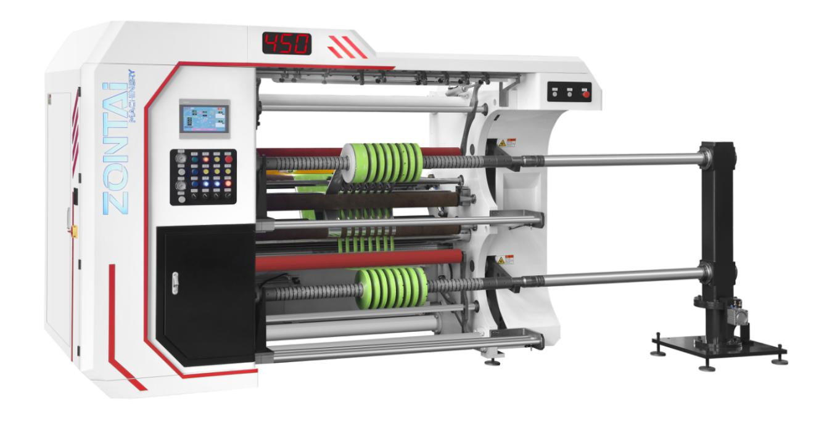
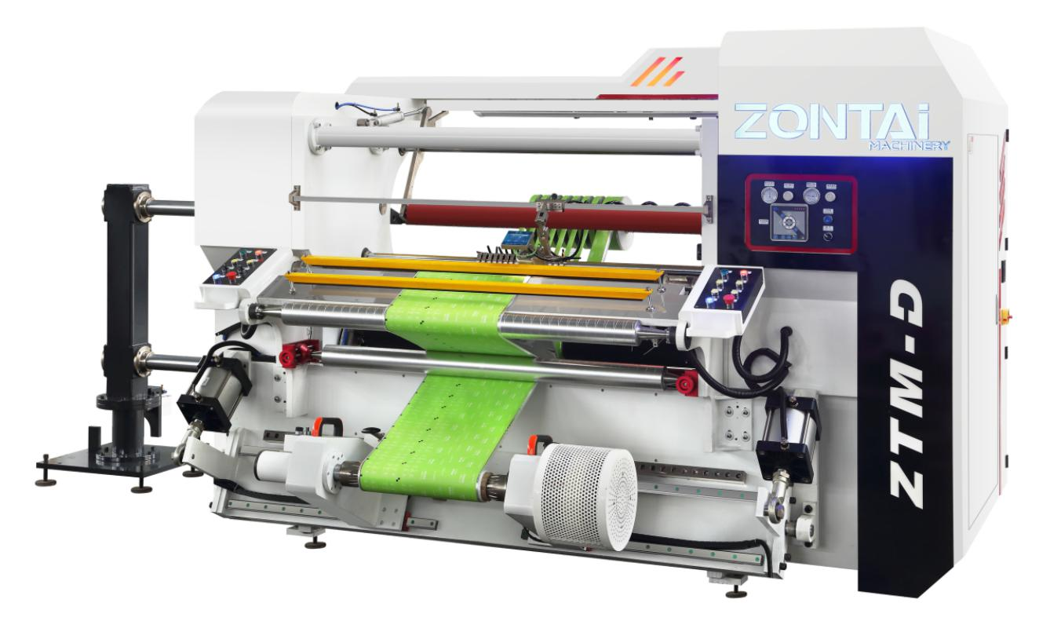
Uses:
The machine applies to slit cellophane, PET, OPP, CPP, PE, PS, PVC and computer security labels, electronic computers, optical materials, film roll, foil roll, all kinds of paper rolls, film and printing of various materials.,etc
Main technical parameter：
Jumbo roll width | 1300mm
Diameter of roll | Ø800mm
Diameter of rewinding | Ø600mm
Inner diameter of paper core | 3’’or 76mm(optional:6’’or 152mm)
Slitting speed | 10-400m/min
Tolerance of EPC | ≤0.1mm
Min.width of produce | 50mm
Total power | 15KW
Weight | 4500Kg
overall dimension (L X W X H) | 2000mm x 4200mm x 1840mm

