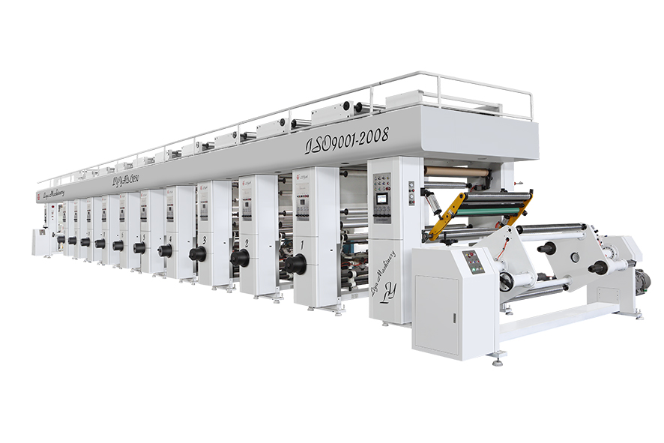

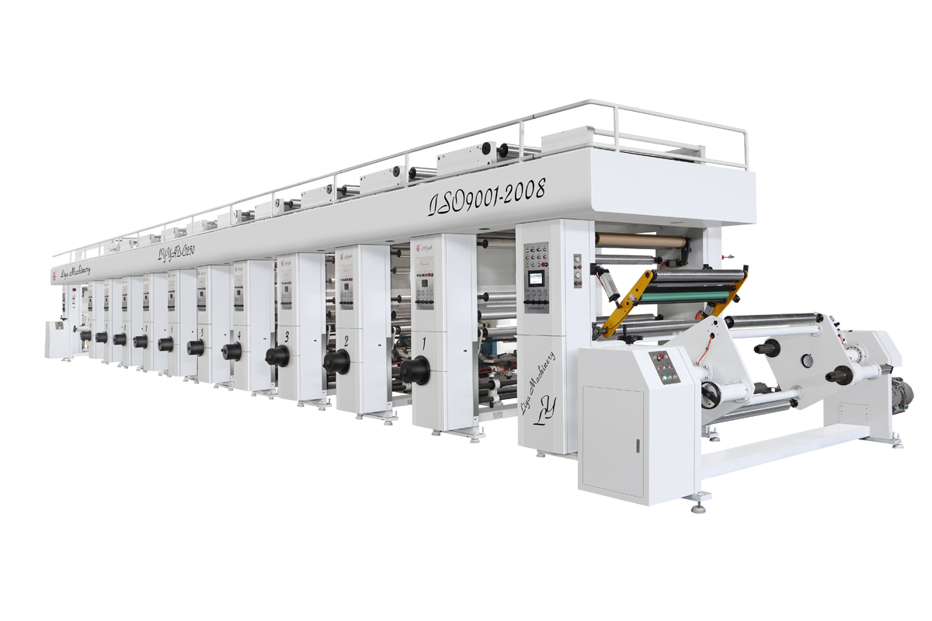LY-YAD-A领先型电脑控制高速凹版彩印机（可选电子轴）
LY- YAD -A Leading Computer Controlled High-speed Gravure Color Printer
产品简介 Product Brief Introduction
LY-AYD-A系列电脑控制高速凹版机，整机采用七电机闭环张力控制，无轴气动装版，触摸屏人机界面操作，自动预套准功能，新卷直径自动检测，高速不停机自动接料，压印胶辊顺序自动下压，集中提起等人性化操作，该机配置先进完善，外形美观，操作简单，是一台领先的高品质的电脑凹版印彩印机.
LY-YAD-A Computer Controlled High-speed Gravure Color Printer, the complete machine adopts seven motors closed-loop tension control, non-shaft pneumatic loading, touch-screen interface, automatic pre-registration function, automatically detect new roller diameter, high-speed non-stop automatic loading and unloading material, pressing printing adhesive roller sequentially automatically press, concentration up such user-friendly operation. This machine has advanced and perfect configuration, beautiful appearance, simple operation, is a leading high-quality computer gravure color printing machine.

主要参数
1 | 印刷宽度 Printing Width | 850/1050/1250mm
2 | 最高印刷速度 Max Mechanical Speed | 机械轴180m/min(印版Ф150)  电子轴200m/min(印版Ф150)
3 | 套印精度 Chromatography Precision | 纵向自动套准±0.10
3 | 套印精度 Chromatography Precision | 横向手动套准±0.10
4 | 放卷直径 Unwinding Diameter | Ф600mm
5 | 张力控制方式Tension Control Way | 七电机四摆辊闭环控制
6 | 张力控制精度Tension Control Way | ±0.1─0.2kg
7 | 接料方式Tension Control Way | 高速不停机自动接料
8 | 印版直径 Printing Plate Diameter | Ф120-280

Main parameter
1 | Printing Width | 850/1050/1250mm
2 | Max Mechanical Speed | 180m/min(printing plateФ150)
3 | Chromatography Precision | Vertical automatic registration±0.10
3 | Chromatography Precision | Horizontal manual registration±0.10
4 | Unwinding Diameter | Ф600mm
5 | Tension Control Way | Seven motors four dance roller closed-loop control
6 | Tension Control Precision | ±0.1─0.2kg
7 | Receiving Material Way | High-speed non-stop automatic receive material
8 | Printing Plate Diameter | Ф120-280

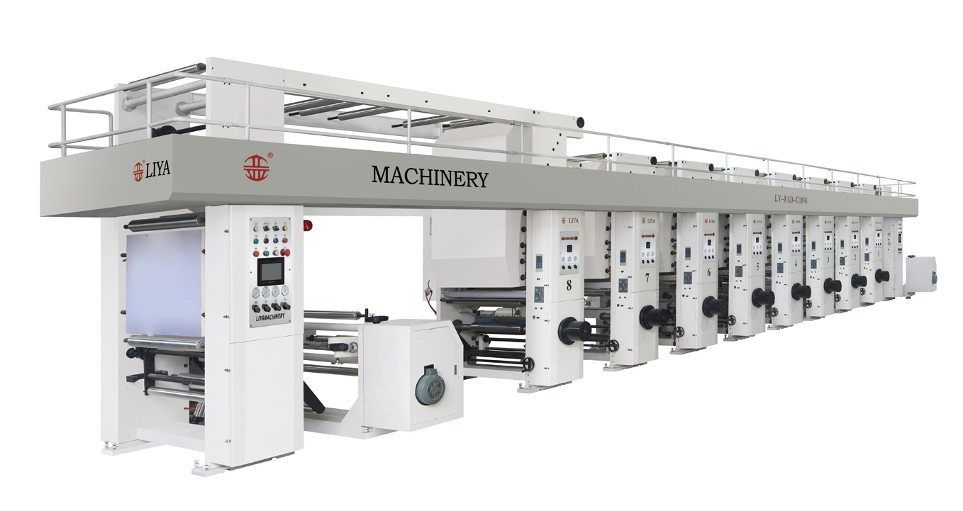

LY- YAD -B实用型电脑控制高速凹版彩印机
LY- YAD -B Practical Computer Controlled High-speed Gravure Color Printer

产品简介
Product Brief Introduction
LY- YAD -B系列电脑控制高速凹版机，整机采用七电机闭环张力控制，无轴气动装版，触摸屏人机界面操作，自动预套准功能，新卷直径自动检测， 高速不停机自动接料，压印胶辊顺序自动下压，集中提起等人性化操作，该机配置先进完善，外形美观，操作简单，是一台实用型高品质的电脑凹版彩印机
LY- YAD -B Computer Controlled High-speed Gravure Color Printer, the complete machine adopts seven motors closed-loop tension control, non-shaft pneumatic loading, touch-screen interface, automatic pre-registration function, automatically detect new roller diameter, high-speed non-stop automatic loading and unloading material, pressing printing adhesive roller sequentially automatically press, concentration up such user-friendly operation. This machine has advanced and perfect configuration, beautiful appearance, simple operation, is a practical high-quality computer gravure color printing machine.

主要参数
1 | 印刷宽度 | 850/1050/1250mm
2 | 最高印刷速度 | 150m/min(印版Ф150)
3 | 套印精度 | 纵向自动套准±0.10
3 | 套印精度 | 横向手动套准±0.10
4 | 放卷直径 | Ф600mm
5 | 张力控制方式 | 七电机四摆辊闭环控制
6 | 张力控制精度 | ±0.1─0.2kg
7 | 接料方式 | 高速不停机自动接料
8 | 印版直径 | Ф120-280
Main parameter
1 | Printing Width | 850/1050/1250mm
2 | Max Mechanical Speed | 150m/min(printing plateФ150)
3 | Chromatography Precision | Vertical automatic registration±0.10
3 | Chromatography Precision | Horizontal manual registration±0.10
4 | Unwinding Diameter | Ф600mm
5 | Tension Control Way | Seven motors four dance roller closed-loop control
6 | Tension Control Precision | ±0.1─0.2kg
7 | Receiving Material Way | High-speed non-stop automatic receive material
8 | Printing Plate Diameter | Ф120-280

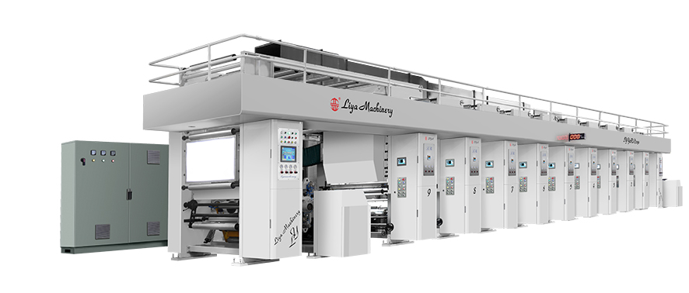
LY- YAD -H型电子轴传动高速凹版彩印机（可选机械轴）
LY- YAD -H High Speed Electric Shaft Gravure Printing Machine（Mechanical Shaft Optional）
产品简介Product Brief Introduction
LY-YAD-H系列电子轴传动高速凹版印刷机，采用直连式电子轴系统，进口伺服电机匹配进口伺服控制器，具有数字化，智能化的特点。纵横向自动套色，每色组套色人机界面操作，操作简单。
LY- YAD –H Series High Speed Gravure Printing Machine with Electric Shaft. Adopt with direct electric shaft system. Imported servo motor work with imported servo controller ,more digitalize and intelligentialize. Auto vertical color registration, each color station work with touch screen.
主要参数
1 | 印刷宽度 | 850/1050/1250mm
2 | 最高印刷速度 | 电子轴300m/min(印版Ф150)
2 | 最高印刷速度 | 机械轴220m/min(印版Ф150)
3 | 套印精度 | 纵向自动套准±0.10
3 | 套印精度 | 横向自动套准±0.10
4 | 放卷直径 | Ф600mm
5 | 张力控制方式 | 七电机四摆辊闭环控制
6 | 张力控制精度 | ±0.1─0.2kg
7 | 接料方式 | 高速不停机自动接料
8 | 印版直径 | Ф120-280

Main parameter
1 | Printing Width | 850/1050/1250mm
2 | Max Mechanical Speed | 220m/min(printing plateФ150)
3 | Chromatography Precision | Vertical automatic registration±0.10
3 | Chromatography Precision | Vertical automatic registration±0.10
4 | Unwinding Diameter | Ф600mm
5 | Tension Control Way | Seven motors four dance roller closed-loop control
6 | Tension Control Precision | ±0.1─0.2kg
7 | Receiving Material Way | High-speed non-stop automatic receive material
8 | Printing Plate Diameter | Ф120-280

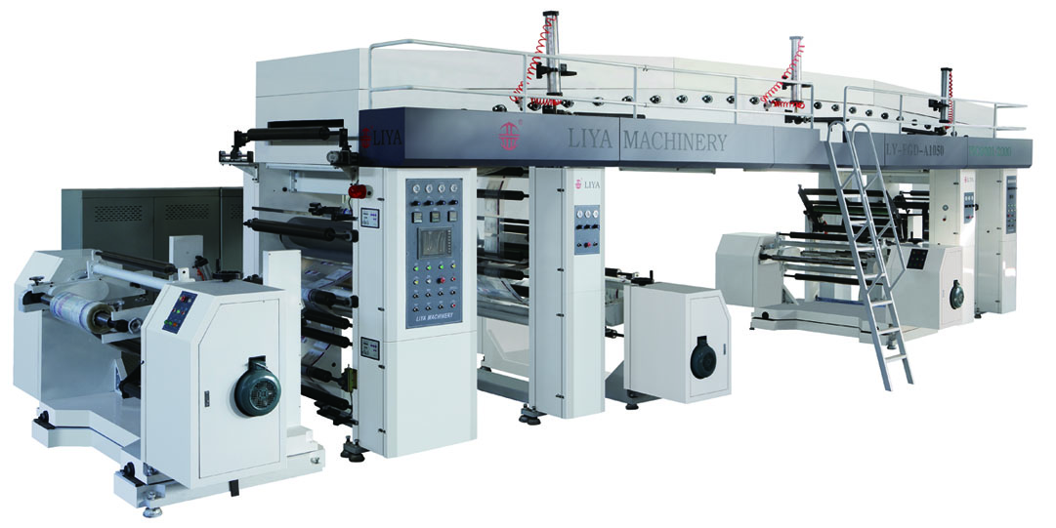

LY-FGD-A型高速电脑控制高速干式复合机
LY-FGD-A High-speed Computer Controlled High-speed Drying Laminator
产品简介Product Brief Introduction
LY-FGD-A系列整机采用国内先进的闭环张力控制系统，实现整机八电机闭环控制，三辊复合，无轴气动装网纹辊，自动均胶装置，气动刮刀，放卷采用EPC纠偏系统，收放料高速不停机自动接料，复合基材预热和成品水冷却装置，触摸屏人机界面操作，气顶式烘箱盖及操作平台，烘箱内导辊与复合电机同步驱动，烘箱出口EPC带纠偏系统，该机配置先进完善，高品质的高速电脑干式复合机。
LY-FGD-A series machine adopts domestic advanced closed-loop tension control system, the complete machine uses eight motors closed-loop control, three rollers laminating, no roller pneumatic loading anilox, automatic equational glue, pneumatic scraper, unwinding uses EPC correction system, high-speed non-stop automatic loading and unloading material, laminating material pre-heating and finished water cooling device, touch-screen interface, gas cap oven cover and operational platform, oven guide roller and laminating motor synchronously driving, oven exit EPC with the correction system, it is of perfect configuration, high-quality high-speed computer drying laminating machine.
主要参数
1 | 机械最高速度 | 200m/min
2 | 放卷直径 | Ф600mm
3 | 张力控制方式 | 八电机闭环张力控制
4 | 走料方式 | 自动纠边EPC
5 | 接料方式 | 高速不停机自动接料
6 | 干燥方式 | 四段封闭式烘箱
7 | 烘箱长度 | 10500mm
8 | 复合宽度 | 850/1050/1250mm

Main parameter
1 | Max Mechanical Speed | 200m/min
2 | Unwinding Diameter | Ф700mm
3 | Tension Control Way | Eight motors closed-loop tension control
4 | Moving Material Way | Automatic deviation corrector LPC
5 | Receiving Material Way | High-speed non-stop automatic receive material
6 | Drying Way | Four parts closed oven
7 | Oven Length | 12000mm
8 | Laminating Width | 850/1050/1250mm

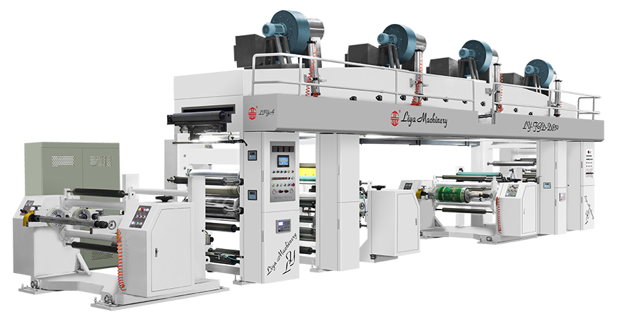

LY-FGD-D高速电脑控制高速干式复合机
LY-FGD-D High-speed Computer Controlled High-speed Drying Laminator
产品简介Product Brief Introduction
LY-FGD-D系列整机采用国内先进的闭环张力控制系统，实现整机四电机闭环控制，三辊复合，无轴气动装网纹辊，自动均胶装置，气动刮刀，放卷采用LPC纠偏系统，收卷自动接料， 成品水冷却装置，触摸屏人机界面操作，气顶式烘箱盖及操作平台，烘箱内导辊与复合电机同步驱动，烘箱出口带纠偏装置，该机配置先进完善，高品质的高速电脑干式复合机。
LY-FGD-D series machine adopts domestic advanced closed-loop tension control system, the complete machine uses four motors closed-loop control, three rollers laminating, no roller pneumatic loading anilox, automatic equational glue, pneumatic scraper, unwinding uses LPC correction system, winding automatic unloading material, finished water cooling device, touch-screen interface, gas cap oven cover and operational platform, oven guide roller and laminating motor synchronously driving, oven exit with the correction system, it is of perfect configuration, high-quality high-speed computer drying laminating machine.

主要参数
1 | 机械最高速度 | 160m/min
2 | 放卷直径 | Ф600mm
3 | 张力控制方式 | 四电机闭环张力控制
4 | 走料方式 | 自动纠边LPC
5 | 接料方式 | 收卷自动接料
6 | 干燥方式 | 四段封闭式烘箱
7 | 烘箱长度 | 9600mm
8 | 复合宽度 | 850/1050/1250mm

Main parameter
1 | Max Mechanical Speed | 160m/min
2 | Unwinding Diameter | Ф600mm
3 | Tension Control Way | Four motors closed-loop tension control
4 | Moving Material Way | Automatic deviation corrector LPC
5 | Receiving Material Way | Winding automatic receive material
6 | Drying Way | Four parts closed oven
7 | Oven Length | 9600mm
8 | Laminating Width | 850/1050/1250mm

LY－FWD－A型电脑无溶剂复合机
LY－FWD－A Computer Solventless laminator
产品简介Product Brief Introduction

LY－FWD－A型电脑无溶剂复合机采用无溶剂胶粘剂新工艺技术对薄膜及轻纸张材料进行复合加工的环保型高新科技产品，我公司设计的FWD-A型无溶剂复合机是根据国际环保节能新工艺技术及我公司多年生产软包装设备的经验而精心设计的设备，整机结构设计合理，加工精度高，同时整机控制系统功能齐全，自动化程度高，工业PLC控制，人机界面操作，电控元件均采用国内外优质品牌，保证了设备质量的稳定性。
LY－FWD－A computer solventless laminator is a new environmental protection high-tech machine for laminating film and paper material using solventless adhesive new technology. FWD-A-type solventless laminator well designed by our company is according to international environmental protection energy-saving new technology and years of experience in the production of soft packaging equipments. The whole machine’s structure is reasonable, high precision processing, fully functional control system, high degree automation, industrial PLC control, touch-screen interface, electrical control components adopt high quality brand at home and abroad to ensure the stability of the quality of the machine.

适用基材suitable material：BOPP/PET/LDPE/OPA/AL/CPP/PAPER
- 整机控制系统采用可编程PLC控制，人机界面操作，实现生产过程控制的自动化控制，达到国际同类设备先进水平。
The whole machine uses programmable PLC control, touch-screen interface, production process automation controlling, reached the international advanced level among similar equipments.

- PLC负责整机张力，速度、生产工艺等数据的输入及预处理，并负责整机软件的反馈控制
PLC is responsible for the data inputting of whole tension, speed, production processes and other preprocessing, and responsible for the whole software feedback control.

3. 整机由第一放卷、供胶系统、无溶剂涂布、第二放卷、复合、冷却、收卷和主控系统八大部件组成。
The whole machine is composed of eight parts, first unwinding, adhesive-supplying system, solventless adhesive coating, second unwinding, laminating, cooling, winding and main controlling system.

4无溶剂涂布装置采用高精度的五辊逆向顺向差速结构，并由变频电机驱动，精确控制速度及涂布量。
The solventless coating device uses high-precision five-roll reverse and forward differential speed structure, drove by variable frequency motor, precise controlling of speed and coating amount.

- 无溶剂双组份供胶装置由立亚公司与国内科研机构共同开发，质量稳定，性价比高。
The solventless adhesive two-component supplier device is provided by Liya Company and domestic research institutions together, stable quality, cost-effective.
- 放卷及收卷装置的结构为单轴单工位，无轴气顶装置，或气胀轴安全夹头装置，配置装料由液压小车方便装卸膜料，并在放卷配EPC自动纠边系统。
The structure of unwinding and winding device is uniaxial single-station, no shaft gas cap device or air shaft safety chuck device, configured loading material is unloaded by hydraulic trolley, and unwinding equipped with EPC automatic deviation corrector system.

- 放卷及收卷机构的驱动及自动张力控制系统由AC电机、编码器、低摩擦气缸、精密调压阀及交流矢量变频变频器。张力控制程序模块组成，具备速度同步，张力锥度变化自动控制功能。
The drive of unwinding and winding and automatic tension control system is composed of AC motor, encoder, low-friction cylinder, precision pressure regulator valve, vector frequency inverter and tension control program modules, synchronized with the speed, tension taper changing automatically controlling.
- 复合装置由下钢辊、胶辊、复合辊、冷却辊四辊组成，AC电机驱动，变频闭环控制。
The laminating device is composed of four parts, steel roller, adhesive roller, laminating roller and coolling roller. Drove by AC motor, variable frequency closed-loop control.
- 被动辊全部使用硬质铝合金管材，（表面阳极硬性处理）
The passive roller uses hard aluminum alloy pipe (hard anodized surface treatment).
- 整机精品意识制造及优化的工业设计
The whole machine is of excellent manufacturing and optimizational industrial design.

技术参数
1 | 型号 | LY-FWD-A850/1050/1250
2 | 收放卷最大直径 | Ф800mm
3 | 最高机械速度 | 300m/min
4 | 涂布量 | 1－3.5g/m
5 | 机器传动方式 | 变频和伺服传动
Main parameter
1 | Model | LY-FWD-A850/1050/1250
2 | Max Unwinding/winding Diameter | Ф800mm
3 | Max Mechanical Speed | 300m/min
4 | Coating Amount | 1－3.5g/m
5 | Machine Driving Way | Frequency conversion and servo drive

